# Game DesignDocument

### Title Page

* Game Name: Legend X
* Game Logo:



* Game Catch Phrase: "Legends never die!"
* Document Type: Microsoft Word 2013
* Document Version: 1.0.0

### Credit Page

* Document Purpose: Informative
* Document Version: 1.0.0
* Working Title: Legend X
* Game Concept: Sci-FI, Fantasy
* Game Document Author: Brandon Castaing, Darragh Ruane, Jonathan Theodore

### Introduction

Legend X is an Action-Role playing game played in the 3rd person. The player starts out as the main hero of the series, Xon and finds out more about how his storyline connects with other characters in the game, unlocking them in the process. The goal of the game is to stop the main antagonist's ambitions to revive an evil general for the purpose of world conquest.

### Game Analysis

Legend X is a third person role playing game that incorporates a fighting style similar to Kingdom Hearts, a world and map exploration to DBZ, and the artistic and visual appeal of Megaman. As Xon finishes levels unveiling the immersive storyline of the game, characters and power-ups are unlocked. The game will feature co-op capabilities for the campaign, reminiscent of Dragon Age and the ability to play online multiplayer arena dueling with unlocked or modified characters.

### Game Description

* Genre: 3rd person live action fantasy RPG
* Game Elements: Shooting, Collecting, Combat (melee, swords, magic),
* Game Content: Drama
* Theme: Fantasy
* Style: Action ("hack & slash")
* Game Sequence: Linear-Storylines
* Player: 4

### Game Reference

* Game Taxonomy
  + Game/Narrative
* Player Immersion
  + Narrative
  + Emotional
  + Mental
  + Tactical
* Reference
  + Megaman
  + Kingdom Hearts
  + DragonBall Z
  + Final Fantasy

### Game Technical

* Technical Form
  + 3D
* View
  + 3rd person
* Platform
  + PC
* Language
  + C#
* Device
  + PC

### Game Atmosphere

Mood board

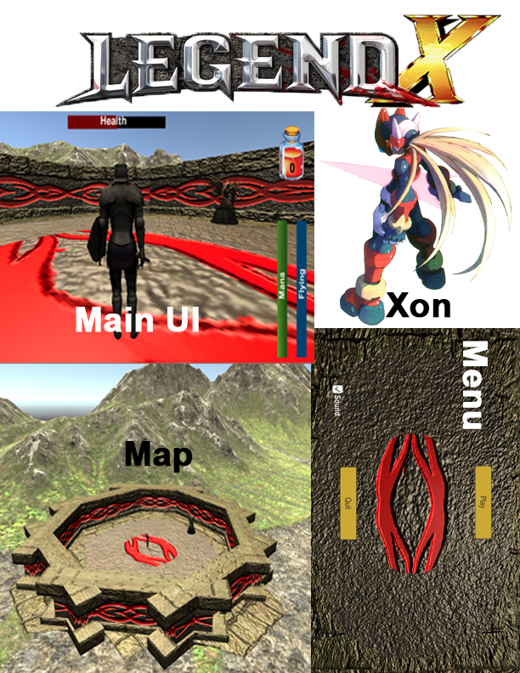

Tiberion (Main antagonist, inspired by Megaman's Colonel)

*below are the characters that the player would encounter as the game progresses some of which would be unlockable

|  |  |  |  |
| --- | --- | --- | --- |
| Character Name | Physical Features | Dominant Traits | Backstory |
| Xon | * Fights with a sword (phoenix blade) * Controls fire * Red and gold armor * Long Blonde hair (see Zero) * X-shaped scar across his face | 1) Easy going attitude that can switch into at times blind rage when his teammates are harmed  2) Strong sense of justice and duty | Revived warrior seeking to discover his mysterious past. Eliza finds him and his artifact in a jungle. It is later revealed that he, like his brothers, host the spirits of ancient creatures of war inside of them which give them different powers from normal warrior class Neo-humans. Xon has the spirit of the Dragon Phoenix, Articus |
| Eliza Cindare | * Fights with her own inventions * Long red hair(a more human version of Megaman's Iris) * 3Despite being a rich heiress she is was also a highly trained soldier so slender but athletic build * After the Tundra zone Eliza does some training with Xon, after the siege she discovers she has an affinity for fire-based abilities as well (cannot control it like Xon can however) | 1) Extremely intelligent and a hard worker. This usually ends in her becoming the brains behind most operations  2) Can be angered easily | Researcher for the government and heiress to giant tech firm Cindare corp. She is sent to investigate a mysterious structure that appeared in a jungle and ended up reviving Xon. She now is trying to help him remember who he is, while researching the origins of his strange powers |
| Tiberion (main antagonist) | * Body builder type build, since he's been a soldier all his life * Black hair * Sinister smile * Gains black armor and a horned helm post Moon Temple | * Headstrong and only really trusts in himself * Has always felt overshadowed by for two reasons. She never had to be a soldier, which would have given him more limelight, and she essentially stopped one of his key missions from failing long ago. | Eliza's colleague and arch-rival who is assigned to the same mission as Eliza that caused Xon's revival. Since he has always felt one-upped by Eliza he sees the discovery of Arcus and Xon's power as opportunity to seek control of it for himself. In the prelude it is revealed that he finds a black compass. The Compass develops a conscience that influences his actions after the Jungle event. |
| Nal Takari | * Tall slender * Black hair * Asian * Incredible marksmen and cyber technician * Builds a red fighter suit close to Excarius's post crashlanding but with added weaponry (lasers rockets, jetpacks, etc) | 1)Intellectual with a devil may care attitude  2)Hates feeling helpless so take sit upon himself to study his teammates battle data thoroughly so he can contribute with his newly made suit | Long time- friend and colleague of Eliza and excellent marksman. After extensively analyzing Xon's fighting style and meeting the crashlanders, he builds his own suit to become a more effective fighting member of the team (this does not happen uintl after the Crashlander fight) |
| Excarius(crashlander) | * Design based around Copy X and the cloaked version of Megaman X | 1)Has tech skills that rival Elizas  2) Cautious and strategic | A foreign soldier who crashlands at the Tundra zone. Was one of the elite soldiers for his home army but due to one of the more recent battles his body was decimated. Since he was also heavily involved with the research department he guided his team on how to fuse his body with machinery |
| Arcus the Shining Knight | * Fights with a two-handed longsword made of gold * Has golden armor * can spawn a golden shield on left arm | * Attitude and mannerism extremely close to Ned Stark (solemn, fatherlike, with a strong sense of duty) * Seems to remember most about his past before his death, but very vaguely | During Tiberion and Xon's initial research trials with Xon, he tracks them down claiming to have also awoken recently to have been a mentor to Xon long ago. |
| Zeria (crashlander) | * Designed to be like a mecha Xon * Weapons: a saber, a chain rod, a boomerang shield, a single fire arm gun | * Fight now ask questions later type | A foreign soldier who crash lands at the Tundra zone.Whereas Excarius is more of the marksmen and brains of their duo, Zeria is a brawler and swordsman who can also shoot. Before Excarius suffered his injuries Zeria's body was almost obliterated in battle and was believed dead. Excarius and his team salvaged his brain and put it inside a mecha soldier that was in development. The design was based around how people thought Xon fought from old legends |
| Crylorga (Introduced at the Tundra zone, only playable after the Cindare Corps siege) | * Wears a back cape made of four closely spaced crystals that spread and stick out when he's engaged in battle (see Prometheus from Megaman ZX) * Wears blue armor with shoulder pads made of crystal and crystals on his helm * Abilities are a close combination of Kimimaro (Naruto) and Wolverine. Except instead of bones or adamantium he uses Chrysalline * Can make crystals spawn by hitting the ground * Can teleport to any crystal thrown or spawn but at a lot of energy cost * Spirit weapon: claymore made of cystal with three spikes on each side | * Light-hearted humor like XOn but extremely rash and loves to fight * Slow but extremely powerful, he produces the hardest known substance and can cut through virtually anything with his claymore at full strength | First of Xon's brothers to be discovered in the game. Is first discovered asleep and is taken by Tiberion. First appears as a mini boss while brainwashed during the Cindare Corps siege.WHen he is added to the team he reveals that all he remembers before this death was screaming at Xon not to do something in a giant battle then a light appeared..  Crylorga has the spirit of the Crystal ground dragon, Terria |
| Monklay (Not introduced until after the Moon Temple) | * Wears darker blue armor. His helmet has two spikes that either turn red or moon yellow depending on his fighting style at the time. * Lunar based powers are designed to use the forces of gravity to repel objects. Or he can throw moon shaped shuriken and boomerangs * Solar based powers are designed to use the forces of gravity to draw objects into some sort of powerful heat source. He can also make the aforementioned boomerangs and shuriken explode with these powers * Fights with a rapier that helps him cast both his lunar and solar powers, is also arguably the best swordsman of the brothers | * The quiet and reserved brother * Extremely wise, and is usually the who keeps Crylorga's rash behavior in check | The second of Xon's brothers to be discovered in the game. Crylorga has the power of the cosmic dragon, Myranovus. |

## Audio Description

### Sound Clips

1. Travel

* Footsteps.mp3 - Walking sound
* Wind.mp3 – Flying sound

1. Fighting

* Laser Gun.mp3 - Basic futuristic enemy fire sound
* Ray Gun.mp3 - Boss' gun fire sound
* Sword Clash.mp3 - Basic sword clashing sound
* Sharp Punch.mp3 - Basic melee sound
* Fire Burning.mp3 - Xon's fire power sound

1. Enemies

* Maniacal Laugh.mp3 - Boss' laugh
* Mountain Lion.mp3 - 1st animal's chasing sound
* Hell (Ice monster).mp3 - 2nd animal's chasing sound

### Music Style/Genre

* All background music was originally produced
  + Title Screen Song: Highnoon Samurai LXU.mp3
  + Tutorial stage song: HTC. Mp3 (Hyperbolic Time Chamber)

## Game Play

The player, Xon, is assigned missions from Eliza’s HQ as well as the government. The player learns how the game works in a fun and simple tutorial at the beginning of the game. Once they have passed the tutorial, they can begin taking part in game story missions. These missions take you on an adventure as Xon in a race against Tiberion to gain key artifacts that have appeared after the LegendX event. Each mission has enemies, puzzles and boss fights to keep the player involved and entertained.

### Key Features

* Number of Levels
  + 1
* Number of Enemies
  + 1
* Time of Game Play
  + 10 minutes
* Replay ability
  + Restart by pausing and going to main menu
* Audio Specifications
  + None
* Graphic Specifications
  + Monitor
* Device Compatibility
  + PC
* Number of Players
  + 1
* Online Activities
  + None
* Number/Type Modes
  + Tutorial

# Game Design Document

### Design Version

1.0

### Design Guidelines

The biggest creative restrictions we have is our limited experience with Unity. We have tons of ideas to make the game fun and engaging but finding out the best ways to implement our ideas in Unity will be the biggest hurdle we face.

### Game Design Definitions

* Menu
  + Play
  + Quit
  + Toggle Sound
* Synopsis
  + Start in menu. Press play button to enter tutorial. Follow instructions to beat tutorial. Pause (p) gives ability to toggle sound or return to main menu
* Gameplay
  + User guided through tutorial that teaches them the controls, ends with boss battle.
* Player Control
  + Mouse to look around
  + Buttons and mouse click for actions
* Game Over
  + Win by beating the tutorial (not dying)

### Game Matrix

|  |  |  |
| --- | --- | --- |
| Character Name | Physical Features | Dominant Traits |
| Xon | Fights with a sword (phoenix blade)  Controls fire  Red and gold armor | Easy going attitude that can switch into at times blind rage when his teammates are harmed |
| Eliza Cindare | Fights with her own inventions  Long red hair(a more human version of Megaman's Iris) | Extremely intelligent and a hard worker  Can be angered easily |
| Tiberion (main antagonist) | Body builder type build, since he's been a soldier all his life  Black hair | Headstrong and only really trusts in himself |
| Nal Takari | Tall slender  Black hair  Incredible marksmen and cyber technician | Intellectual with a devil may care attitude |
| Excarius(crashlander) | Design based around Copy X and the cloaked version of Megaman X | Has tech skills that rival Eliza's  Cautious and strategic |
| Arcus the Shining Knight | Fights with a two-handed longsword made of gold  Has golden armor  Can spawn a golden shield on left arm | Attitude and mannerism extremely close to Ned Stark (solemn, fatherlike, with a strong sense of duty)  Seems to remember most about his past before his death, but very vaguely |
| Zeria (crashlander) | Designed to be like a mecha Xon | Fight now ask questions later type |

### Game Flow Chart

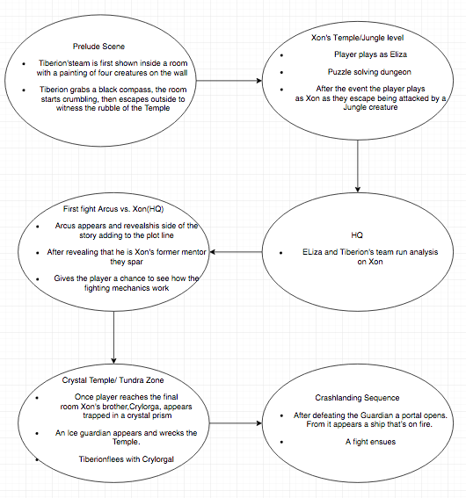

### Player Elements

* Humanoid character armed with a sword, capable of magic and melee attack
* Character capable of waling, running, dodging, blocking, and flying
* Player gets a health bar, a mana bar, and flight bar
* Player can collect potions to heal both mana and health
* All bars regenerate but the flight meter regenerates the fastest since it has no potions

### Player Definition

Default: The player begins the game with only a single sword, no spells, no flying, no items, and with no additional characters. At the end of the tutorial, the player will be able to fly, use items, and learn to fight.

Actions: A player can fight (attack, block, dodge), use spells, fly, interact with the environment, and swap characters at whim.

Information: A player's current health, mana, flying bar, and item inventory are made available at a glance by our HUD.

Default Properties: The player begins the game with only a single sword, no spells, no flying, no items, and with no additional characters. At the end of the tutorial, the player will be able to fly, use items, and learn to fight.

Winning: A player wins the game by defeating Tiberion and fully uncovering the clues to Xon's past life, which involves adding his brothers and other main characters to your party.

Losing: A player loses the game by dying (e.g. losing all of their health). They would have to restart from a previous checkpoint.

### Player Properties

|  |  |  |
| --- | --- | --- |
| Property | Interacts With | Definition |
| Health | Enemies and Damage | Lifepoints |
| Weapons | Enemies, Store, and Looting | Weapons that can be used |
| Spells | Enemies, Scrolls, and Looting | Abilities that can be used |
| Characters | Player | Playable avatars |
| Mana | Player using a spell | Allows player to use an ability |
| Fly | Environment | Allows player to fly |

### Player Rewards

|  |  |  |
| --- | --- | --- |
| Object | Player Affect | Use |
| Potion | Relieved | Health replenished |
| Weapon | Excited | Gain new weapon to use |
| Coin | Hopeful | Purchase items at a store |
| Scroll | Excited | Gain new spell to use |

### UI

The user will be able to move around using the WASD keys or arrow keys, and look around using the mouse. There will be a button to melee attack or attack with your weapon, as well as a button to attack with magic. There will also be a key that allows the user to temporarily fly. There will be a pause key to access the pause menu, as well as a key to interact with other characters.

### HUD

There will be three bars on the heads up display, a health bar that shows the user how much health they have left, an energy bar that shows the user how much magic they have left, and a flight bar that shows how much longer a player can fly for. There will also be a coin count that tells the user how many coins they currently have, as well as a mini map that shows the user where they are and where they should be going. Lastly, there will be an ability toggle that lets the user change between their magic abilities.

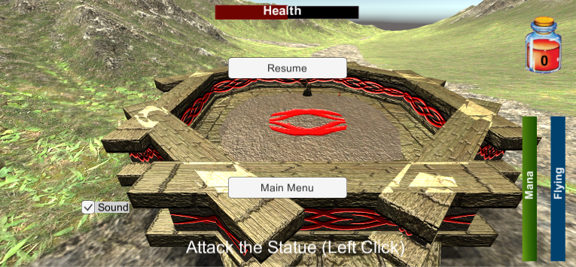

### Player View

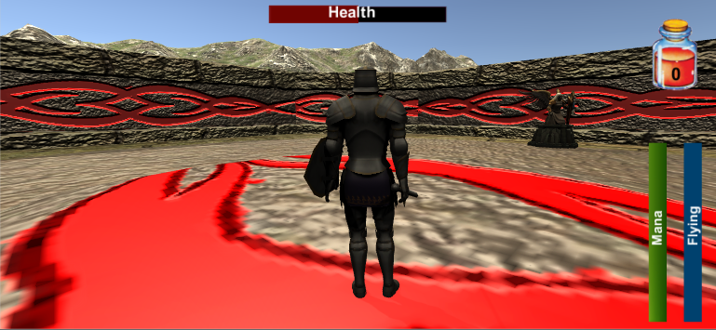

The camera will move when the player moves their mouse left or right. The player's screen view relative to the level's actual size is about 1:20. You can see a large portion of the level from your screen, but it certainly requires navigation and exploring to find all elements of a given level to complete it.

### Antagonistic Elements

* Types of Enemies
  + Tutorial
    - Features a statue dummy that the player can attack and grants potions upon receiving a collision.
    - After completing the tasks with the dummy a humanoid boss appears with the same capabilities as the player
  + Types of enemies
    - Henchmen: humanoid AI that attack the player. Generally have lower health and strength
    - Humanoid bosses
    - Golem bosses (temple guardians)
    - Mini golems/ movable statues
    - Animal like enemies for jungle area

### Antagonistic Definitions

* Any movable object that the player is a capable of hitting as well as take damage from

### Antagonistic Properties

* Health
* Attack power
* Mana power
* Limited flight
* Movement with exception of dummies
* Humanoid enemies

### Antagonistic List

* Tiberion (main antagonist, for the 1st game)
* Henchmen/ humanoid enemies
* Unlockable characters
* Beasts
* Temple Guardians
* Spaceship fighters
* Tiberion’s generals
  + Dioboros
  + Lectro Knight
  + Varus the Knight of Shadows
  + Vicida Kemp
  + Ninja twins

### AI

Our enemies and bosses utilize an artificial intelligence we were familiar with from our favorite games, such as Megaman and DragonBallZ. The enemies in these games utilize a timer and event based action protocol. Simply, the enemies/bosses will begin a new action every x seconds or whenever a certain event (such as reaching a certain health point threshold). We tried to replicate this AI algorithm for Xon's foes throughout the game.

### Global Game Elements

LegendX utilizes an item system that persists throughout Xon's journey. As you play the game, you acquire items which can be used for various purposes, such as healing or increasing damage output. Another persisting element to the game is that Xon can be interchanged with other unlocked characters during the campaign as well as multiplayer. The font-style for the game will always be Batang.

### The Story

The game starts you out as Eliza Cindare, a government researcher on a mission to uncover the secrets of her species past, the Neo-Humans. The mission sends her team as well as the team of her long-time rival, Tiberion, to a newly discovered temple in the middle of a distant jungle on the planet Lacrio. After solving some of the puzzles within the Temple they uncover a shrine room dedicated to the 4 Legendary heroes credited for saving the Neo-Human race from an extinction like that of their ancestors, the Humans. After deciphering prophetic writings on the wall and obtaining a bracelet representing one of the four legendary beasts that the heroes were able to control, the room whites out.

Eliza wakes up in the middle of the jungle with the bracelet in hand, the Temple vanished and an unconscious Xon nearby. The rest of the game proceeds with the player being Xon as the main character. Eliza’s team and Tiberion’s team research what Xon really is, and with the help of the mysterious Arcus the Golden Knight they find out that he is one of the revived warriors of old. With this information the two teams seek to find out, what really happened during the “LegendX” event. What caused the revival of these warriors? Tiberion seeks to answer these questions simply to see how he gain power for himself, while Eliza is trying to help Xon regain his power and memories while also stopping Tiberion’s selfish desires.

### The Story Copy

Government researcher Eliza Cindare along with her long time rival and colleague, Tiberion Karamu, take their respective teams on a mission to a temple in a distant jungle. The temple has never been seen before and it is speculated to hold some clues into the nature of how their species, the Neo-Humans evolved from their extinct ancestors, the humans. After solving the puzzles of the Temple the groups uncover a shrine dedicated tot eh four legendary heroes credited with saving the Neo-Humans from their own extinction by ending a massive war. Eliza obtains an artifact from completing the last puzzle but at that moment the rooms starts to shake and whites out. Eliza awakes in the middle of a jungle, with the artifact, an unknown unconscious man by her side, and fins that the Temple is gone. It is later revealed that this man is Xon, one of the hero's of old. Now Eliza must uncover what really happened at the Temple, help Xon regain his memories of the past, and make sure that her rival does not seek out the secrets behind the Legend X event for his own selfish gain.

### Concept Art

### Xon (Model inspired from Megaman Zero)

### 

### Level Design

* In the large-scale view of the game, we have would be one fo the introductory levels of the game
* The player is put into a simple octagonal arena and is prompted to complete a series of instructions
* The instructions tell the player the basic movements and they are directed to perform them on a dummy object (the statue)
* After completing the tasks an ai boos will appear that the player is supposed to defeat.
* The level itself is an arena made from a Temple building kit, that is set outside in the mountains, the player is unable to fly out of the arena however because there are invisible walls

### Level Copy

All of our scripts are included in the .zip file.

### Audio & Sound FX

### Sound Clips

1. Travel

* Footsteps.mp3 - Walking sound
* Wind.mp3 – Flying sound

1. Fighting

* Laser Gun.mp3 - Basic futuristic enemy fire sound
* Ray Gun.mp3 - Boss' gun fire sound
* Sword Clash.mp3 - Basic sword clashing sound
* Sharp Punch.mp3 - Basic melee sound
* Fire Burning.mp3 - Xon's fire power sound

1. Enemies

* Maniacal Laugh.mp3 - Boss' laugh
* Mountain Lion.mp3 - 1st animal's chasing sound
* Hell (Ice monster).mp3 - 2nd animal's chasing sound

### Music Style/Genre

* All background music was originally produced
  + Title Screen Song: Highnoon Samurai LXU.mp3
  + Tutorial stage song: HTC. Mp3 (Hyperbolic Time Chamber)

### Game Architecture

* Title Screen
  + Play button
  + Music toggle button
* Option Screens
  + N/A (pause menu for the future)
* Game Modes
  + Campaign
  + Online Arena (extra)
  + Online/solo mini games (extra)
* End Screens
  + N/A
  + (the only screen that would be added would be a Game Over scene

### Game Architecture Overview

* Menu
  + Play: Starts the game
  + Quit: Exits out of the game
  + Sound Toggle: Toggles Sound
* Pause Screen
  + Resume: Resumes game
  + Main Menu: Returns to the Main Menu Screen
  + Sound Toggle: Toggles Sounds

### Architecture Copy

All of our scripts are included in the .zip file.

### How to Play Copy

* Move(w)
* Look around (mouse)
* Attack (left click)
* Jump (Space)
* Block (X)
* Dodge (Q)
* Flying (F)
* Use potion (2)